**TAX CONNECT**

305th Issue: 4th July 2021 – 10th July 2021

12017

**Knowledge Partner:**



**TAX CONNECT**

**Mumbai  :**A/1001, Cirrus Bldg, Cosmos Paradise; Pokhran Road No. 1, Thane (West), Maharashtra – 400606

**Bangalore**:A-414,Carlton Towers,19th Main; Road Hal Old Airport Rd, Domlur, Bengaluru, Karnataka-560008

**New Delhi :**B-139, 2nd Floor, Transport Nagar, Noida-201301 (U.P)

**Kolkata**  :1, Old Court House Corner, “Tobacco House” 1st Floor, R.No.-13 (North), Kolkata-700001

:Room No 119; 1st Floor; Diamond Arcade; 1/72, Cal Jessore Road; Kolkata – 700055

**Dubai**:AziziFeirouz, 803, 8th Floor, AL Furjan, Opposite Discovery Pavillion, Dubai, UAE

**Contact: +919874466163; +91 9830661254**

**Website:** [**www.taxconnect.co.in**](http://www.taxconnect.co.in)

**Email:** [**info@taxconnect.co.in**](mailto:info@taxconnect.co.in)



**Friends,**

*“Commendable work has been done in the year gone by both in the area of facilitation and enforcement with numerous cases of fraudulent dealers and ITC being registered. The enhanced revenue collection in recent months should now be the 'new normal.”-* Hon’ble Finance Minister Nirmala Sitharaman.

There are some other relevant changes in GST and Income Tax during last week as under:

**MISUSE OF PAN FOR GST REGISTRATION**

As a move aimed towards curbing creation of bogus entities for the purpose of tax evasion, Goods and Services Tax Network has enabled an utility on GST portal ([www.gst.gov.in](http://www.gst.gov.in)) to lodge complaints relating to misuse of PAN for obtaining GST registration. Any person whose PAN has been misused can lodge such complaint. Following that, it would be sent to the concerned tax officer under whose jurisdiction the registration has taken place fraudulently for further action.

**RETAIL & WHOLESALE TRADES INCLUDED AS MSMEs:**

The Government has been decided to include Retail and wholesale trades as MSMEs and they are allowed to be registered on Udyam Registration Portal (https://udyamregistration.gov.in). However, benefits to Retail and Wholesale trade MSMEs are to be restricted to Priority Sector Lending only.

**SECTION 194Q SHALL NOT APPLY FOR THE SPECIFIED TRANSACTIONS:**

Sec. 194Q of the Income Tax Act takes effect from 1st July 2021. As per the recent guidelines, Sec. 194Q shall not apply in relation to transactions in the nature of:

* Securities & Commodities which are traded through a stock exchange or cleared or settled by the recognized clearing corporation
* Electricity, renewable energy certification & energy saving certificates which are traded through power exchange.
* Any sum credited or paid before 1st July.

**We do hope that this bulletin adds value to your professional sphere.**

**Just to reiterate that we remain available over telecom or e-mail.**

**Truly Yours**

**Editor:**

**Vivek Jalan**

Partner - Tax Connect Advisory Services LLP

**Co-Editors:**

**Rohit Sharma**

Senior Manager – Tax Connect Advisory Services LLP

**Rajanikant Choudhury**

Manager - Tax Connect Advisory Services LLP

**Stay Safe and Healthy**

|  |  |  |
| --- | --- | --- |
| S.NO. | TOPICS | PAGE NO. |
| **1]** | **TAX CALENDER** | **4** |
| **2]** | **INCOME TAX** | **5** |
| **CIRCULAR** | CIRCULAR NO 12 OF 2021- STATES EXTENSION OF TIME LIMITS OF CERTAIN COMPLIANCES TO PROVIDE RELIEF TO TAXPAYERS IN VIEW OF THE SEVERE PANDEMIC. |  |
| **3]** | **GST** | **6** |
| **NOTIFICATION AND CIRCULARS** | N. NO. 28/2021-CENTRAL TAX - APPLICABILITY OF B2C DYNAMIC QR CODE PROVISIONS EXTENDED TO 30.09.2021.  CIRCULAR NO. 155/11/2021-GST - GST RATE ON LATERALS/PARTS OF SPRINKLERS OR DRIP IRRIGATION SYSTEM  CIRCULAR NO. 154/10/2021-GST - GST ON SERVICE SUPPLIED BY STATE GOVT. TO THEIR UNDERTAKINGS OR PSUS BY WAY OF GUARANTEEING LOANS TAKEN BY THEM.  CIRCULAR NO. 153/09/2021-DATED 17TH JUNE 2021 - GST ON MILLING OF WHEAT INTO FLOUR OR PADDY INTO RICE FOR DISTRIBUTION BY STATE GOVERNMENTS UNDER PDS |  |
| **4]** | **FEMA** | **7** |
| **CASELAW** | A NOTE OF CAUTION –REGULATORY NON-COMPLIANCE COULD RESULT IN CONTRACTS BEING RENDERED VOID |  |
| **5]** | **CUSTOMS** | **8** |
| **NOTIFICATION** | NOTIFICATION NO. 34/2021- BASIC CUSTOMS DUTY ON CRUDE PALM OIL AND PALM OIL OTHER THAN CRUDE PALM OIL REDUCED TILL 30TH SEPTEMBER 2021. |  |
| **CIRCULAR** | CIRCULAR NO. 13/2021 DATED 1. 7. 2021 - ONLINE FILING OF AEO T2 AND AEO T3 APPLICATIONS: LAUNCH OF VERSION 2.0 OF WEB-APPLICATION FOR FILING, REAL-TIME MONITORING, AND DIGITAL CERTIFICATION. |  |
| **6]** | **DGFT** | **9** |
| **NOTIFICATION** | IMPORT OF POTATOES UNDER EXIM CODE 07019000, IS ALLOWED FROM BHUTAN WITHOUT LICENSE UPTO 30TH JUNE, 2022 VIDE NOTIFICATION NO. 9/2015-202 AND AMENDMENT IN IMPORT POLICY OF ITEMS UNDER HS CODE 1511 90 OF CHAPTER 15 OF ITC (HS), 2017, VIDE NOTIFICATION NO. 10/2015-2020 |  |
| **7]** | **IN STANDS - AN INTEGRATED APPROACH TO GST E-INVOICING, E-WAYBILL & E-RETURN FILING** | **10** |
| **8]** | **IN STANDS –SECTION WISE COMPENDIUM ON GST** | **11** |
| **9]** | **IN STANDS – UNION BUDGET 2021** | **12** |
| **10]** | **LET’S DISCUSS FURTHER** | **13** |

|  |  |  |  |
| --- | --- | --- | --- |
| **Due date** | **Form/Return/Challan** | **Reporting Period** | **Description** |
| **7th July 2021** | [**Form No. 27C**](https://www.taxmanagementindia.com/visitor/detail_forms.asp?ID=758) |  | **Submission of declaration for no TCS u/s 206C(1A) obtained from manufacturer to the Commissioner/Chief Commissioner of Income Tax as the case may be.** |
| **7th July 2021** | [**Form No.**](https://www.taxmanagementindia.com/visitor/detail_forms.asp?ID=1207&kw=Return-for-Non-resident-taxable-person) [**Challan Form ITNS 281**](https://www.taxmanagementindia.com/visitor/detail_forms.asp?ID=844) | **April2021- June 2021** | **Quarterly payment of TDS for payments u/s 192, 194A, 194D or 194H with the prior approval of the Joint Commissioner** |
| **7th July 2021** | [**Challan Form ITNS 281**](https://www.taxmanagementindia.com/visitor/detail_forms.asp?ID=844) | **June 2021** | **Monthly payment of TDS on all types of payments (Except in the case where amounted is credited in the Month of March 31)** |
| **7th July, 2021** | [**Challan Form ITNS 281**](https://www.taxmanagementindia.com/visitor/detail_forms.asp?ID=844) | **June 2021** | **Monthly payment of TCS u/s 206C (other than government assessee)** |
| **7th July, 2021** | [**Form No.26QB**](https://www.taxmanagementindia.com/file_folder/2013-14/Form26QB.pdf) |  | **Payment on transfer of certain immovable property other than agricultural land** |
| **10th July, 2021** | [**GSTR - 1**](https://www.taxmanagementindia.com/visitor/detail_forms.asp?ID=1198&kw=Details-of-outward-supplies-of-goods-or-services) | **May 2018** | **Details of outward supplies of goods or services [Filing of Return to be regular For the Month of May 2018 onward** |

CIRCULAR

**CIRCULAR No 12 of 2021 - STATES Extension of time limits of certain compliances to provide relief to taxpayers in view of the severe pandemic.**

**Our Comments:** Central Board of Direct Taxes, provided relaxation in respect of the following compliances as under:

1. Objections to Dispute Resolution Panel (DRP) and Assessing Officer under section 144C of the Act, for which the last date of filing under that Section is 18 June, 2021 or thereafter, may be filed within the time provided in that Section or by 31st August, 2021, whichever is later.
2. The Statement of Deduction of Tax for the last quarter of the Financial Year 2020-21, as extended to 30th June, 2021 vide Circular No.9 of 2021, may be furnished on or before 15 July, 2021.
3. The Certificate of Tax Deducted at Source to the employee by 15th June, as extended to 15th July, vide Circular No.9 of 2021, may be furnished on or before 31st July, 2021;
4. The Statement of Income paid or credited by an investment fund required to be furnished on or before 15th June, 2021, as extended to 30th June, may be furnished on or before 15th July, 2021.
5. The Statement of Income paid or credited by an investment fund to its unit holder for the Previous Year 2020-21, required to be furnished on or before 30th June, 2021, as extended to 15th July, 2021 vide Circular No.9 of 2021, may be furnished on or before 31st July, 2021;
6. The application under Section 10(23C), 12AB, 35(1)(ii)/(iia)/(iii) and 80G of the Act in Form No. 10A/ Form No.10AB, for registration/ provisional registration/ intimation/ approval/ provisional approval of Trusts/ Institutions/ Research Associations etc. may be made on or before 31st August, 2021.
7. The compliances to be made by the taxpayers such as investment, deposit, payment, acquisition, purchase, construction or such other action, by whatever name called, for the purpose of claiming any exemption under the provisions contained in Section 54 to 54GB of the Act, may be completed on or before 30th September, 2021.
8. The Quarterly Statement furnished by authorized dealer in respect of remittances made for the quarter ending on 30th June, 2021, required to be furnished on or before 15th July, 2021, may be furnished on or before 31st July, 2021;
9. The Equalization Levy Statement in Form No. 1 for the Financial Year 2020-21, which is required to be filed on or before 30th June, 2021, may be furnished on or before 31st July, 2021:
10. The Annual Statement required to be furnished which is required to be filed on or before 29th June, 2021 , may be furnished on or before 31st July, 2021;
11. Uploading of the declarations received from recipients which is required to be uploaded on or before 15th July,2021, may be uploaded by 31st August,2021:
12. Exercising of option under sub-section (1) of Section 245M of the Act in Form No. 34BB which is required to be exercised on or before 27th June, 2021 may be exercised on or before 31st July, 2021.

**[For further details please refer the circular].**

**NOTIFICATION**

**Notification No. 28/2021-Central Tax Dated: 30th June, 2021- Applicability of B2C dynamic QR code provisions extended to 30.09.2021**

**Our Comments:** CBIC vide notification no 28/2021 dated 30.06.2021 extended applicability of B2C dynamic QR code provisions to 30.09.2021 instead of from July 1, 2021.

**[For further details please refer the notification]**

**CIRCULAR**

**Circular No. 155/11/2021-GST Dated the 17th June, 2021- GST rate on laterals/parts of Sprinklers or Drip Irrigation System**

**OUR COMMENTS:** Laterals/parts to be used solely or principally with sprinklers or drip irrigation system, which are classifiable under heading 8424, would attract a GST of 12%, even if supplied separately. However, any part of general use, which gets classified in a heading other than 8424, in terms of Section Note and Chapter Notes to HSN, shall attract GST as applicable to the respective heading.

**[For further details please refer the circular]**

**CIRCULAR**

**Circular No. 154/10/2021-GST Dated the 17th June, 2021- GST on service supplied by State Govt. to their undertakings or PSUs by way of guaranteeing loans taken by them.**

**OUR COMMENTS:** It has been clarified that guaranteeing of loans by Central or State Government for their undertaking or PSU is specifically exempt under said entry no. 34A of Notification no. 12/2017-Central Tax (Rate) dated 28.06.2017.

**[For further details please refer the circular]**

**CIRCULAR**

**Circular No. 153/09/2021-DATED 17TH JUNE 2021 -** **GST on milling of wheat into flour or paddy into rice for distribution by State Governments under PDS**

**OUR COMMENTS:** Public Distribution specifically figures at entry 28 of the 11th Schedule to the constitution, which lists the activities that may be entrusted to a Panchayat under Article 243G of the Constitution. Hence, said entry No. 3A would apply to composite supply of milling of wheat and fortification thereof by miller, or of paddy into rice, provided that value of goods supplied in such composite supply (goods used for fortification, packing material etc) does not exceed 25% of the value of composite supply.

In case the supply of service by way of milling of wheat into flour or of paddy into rice, is not eligible for exemption under Sl. No. 3 A of Notification no. 12/2017-Central Tax (Rate) dated 28.06.2017 for the reason that value of goods supply in such a composite supply exceeds 25%, then the applicable GST rate would be 5% if such composite supply is provided to a registered person, being a job work service (entry No. 26 of notification No. 11/2017- Central Tax (Rate) dated 28.06.2017).

**[For further details please refer the circular]**

CASE LAW

**ASHA JOHN DIVIANATHAN VERSUS VIKRAM MALHOTRA & ORS [SUPREME COURT OF INDIA].**

## **Brief:** A Note of Caution –Regulatory Non-Compliance Could Result in Contracts Being Rendered Void

**Our comments:** Briefly, the question before the Supreme Court in Asha John was whether a gift-deed entered into by a foreign national without the assent of the Reserve Bank of India ("RBI"), as required under Section 31 of the (now repealed) Foreign Exchange Regulation Act, 1973 ("FERA"), conferred a valid title on the beneficiary of such deed. The question assumed prominence on account of conflicting decisions between various High Courts in the country. In some these decisions, for instance, courts distinguished between: (a) general statutory proscription of certain transactions, inviting penalties for a contravention and (b) express statutory declarations holding such transactions as void. These decisions held that Section 31 of FERA fell under the former category and were not void contracts per se. While this may be the first instance of the Supreme Court authoritatively affirming the "peremptory condition" under Section 31 of FERA, the proposition of law is hardly novel.4 For instance, Section 108 of the Companies Act, 1956 which states that a company "shall not register" a transfer of shares unless a duly stamped instrument along with other documents is provided, was held by another three-judgement of the Supreme Court to be mandatory and any default rendered the concerned transaction void. With this decision, it will become onerous for parties to contend that a prohibition/ penal consequence under a different statute shall not result in the nullity of a contract as contemplated under Section 23 of the Contract Act, 1872 (Contract Act). In other words, the violation of a mandatory provision governing a contract would render the object or consideration of the contract "forbidden by law" or to be of "such a nature that if permitted, it would defeat the provisions of any law", resulting in nullifying the contract under Section 23 of the Contract Act. While the decision of the Supreme Court in Asha John is likely to trigger greater interest in the construction of provisions in other statutory enactments, it may also have serious implications for the arbitration regime in India, particularly in the conception of "public policy". It is often observed that parties seeking to avoid arbitration in international contracts take liberal recourse to alleging violations of the Foreign Exchange Management Act, 1999 (FEMA). Often times, the same party that is obligated to secure appropriate regulatory approval may use its own failure to secure approvals to avoid liability by claiming the subject contract to be void. Particularly in these circumstances, additional caution is necessary in applying Asha John, so as to avoid its use as an axe to frustrate Indian court proceedings in aid of international commercial arbitration. Courts may do well to avoid entertaining arguments to declare contracts as void for being violative of other enactments at the stage of reference to arbitration or in the course of granting interim relief. The arbitration agreement, being a distinct contract, shall not be affected by such a declaration and such arguments may be left to be considered by arbitral tribunals.

**[In favour of the petitioner]**

**NOTIFICATION**

**NOTIFICATION NO. 34/2021-Customs dated: 29th June, 2021 - BASIC CUSTOMS DUTY ON CRUDE PALM OIL AND PALM OIL OTHER THAN CRUDE PALM OIL REDUCED TILL 30TH SEPTEMBER 2021**

**Our Comments:** This notification exempts the goods of the description specified in column (3) of the Table below, falling within the Chapter, heading, sub–heading or tariff item of the [First Schedule](https://www.taxmanagementindia.com/visitor/detail_act.asp?ID=19784) to the [Customs Tariff Act, 1975 (51 of 1975)](https://www.taxmanagementindia.com/visitor/acts_rules_provisions.asp?ID=35) specified in column (2) of the said Table, when imported into India, from so much of the duty of customs leviable thereon under the said First Schedule, as is in excess of the amount calculated at the standard rate specified in the corresponding entry in column (4) of the said Table, namely –

|  |  |  |  |
| --- | --- | --- | --- |
| **S. No.** | **Chapter, heading, sub-heading or tariff item** | **Description** | **Standard Rate** |
| **(1)** | **(2)** | **(3)** | **(4)** |
| 1. | 1511 10 00 | Crude Palm Oil | 10% |
| 2. | 1511 90 | All goods (RBD Palm Oil, RBD Palmolein, RBD Palm Stearin and any Palm Oil other than Crude Palm Oil) | 37.5% |

This notification shall come into effect on 30th June 2021 and will remain in force upto and inclusive of the 30th September, 2021.

**[For further details please refer the Notification]**

**CIRCULAR**

**CIRCULAR N. 13/2021 DATED jULY 01 2021 - Online filing of AEO T2 and AEO T3 applications: Launch of Version 2.0 of web-application for filing, real-time monitoring, and digital certification.**

**Our comments:** This updated version of the existing web application will be made accessible for both applicants and the customs officials from 07.07.2021. The new version (V 2.0) of the web application is designed to ensure continuous, real-time, and digital monitoring of the physically filed AEO T2 and AEO T3 applications for timely intervention and expedience. The AEO T2 and AEO T3 applicants, on submission of the physical documents in the jurisdictional Principal Chief Commissioner/ Chief Commissioner’s office (AEO Cell), shall register on AEO web application. On successful registration, the applicant shall upload the duly filled relevant annexures for their AEO T2 or AEO T3 application, as the case may be. The applicants who are already registered (Existing T1 status holder applying for T2) at aeoindia.gov.in are not required to register again. Once the relevant annexures are uploaded by the applicant, the applicant will be able to monitor the processing of their application at each stage in real time on their dashboard. In addition, in case of any deficiency in the application, the same can be responded through online upload of required additional documents by the applicant  on the web application itself. A step wise guide for filing of AEO T2 and AEO T3 application by the applicant is available on the CBIC website under the “Indian AEQ Programme”.

**[For further details please refer the Circular]**

NOTIFICATION

**Import of potatoes under Exim Code 07019000, is allowed from Bhutan without license upto 30th June, 2022 vide Notification No. 9/2015-2020 and Amendment in import policy of items under HS Code 1511 90 of Chapter 15 of ITC (HS), 2017, VIDE NOTIFICATION NO. 10/2015-2020**

**Our Comments:** Amendment of import policy conditions for items under Exim code 07019000 of Chapter 07 of ITC (HS), 2017, Schedule —I (Import Policy) and Amendment in import policy of items under HS Code 1511 90 of Chapter 15 of ITC (HS), 2017 notified.

The Central Government hereby amends the policy conditions of items under Chapter 07 and Chapter 15 of ITC (HS), 2017, Schedule —I (Import Policy).

|  |  |  |  |  |
| --- | --- | --- | --- | --- |
| **E**xim code | **Item description** | **Import policy** | **Existing policy condition** | **Revised policy condition** |
| 07019000 | Potatoes, fresh or chilled: other | Restricted | Import of Potatoes from Bhutan is permitted freely, without  any Bhutan license, up   to 31st January 2021 | Import              of Potatoes  from is permitted   freely, without           any license, up to 30th June, 2022. |
| 1511 90 10 | Refined bleached deodorised palm oil | Restricted | Free | Imports are not permitted through any port in Kerala. |
| 1511 90 20 | Refined bleached deodorized palmolein | Restricted | Free | Imports are not permitted through any port in Kerala. |
| 1511 90 90 | Other | Restricted | Free | Imports are not permitted through any port in Kerala. |

**Effect of the Notification: Import of potatoes under Exim Code 07019000, is allowed from Bhutan without license upto 30th June, 2022 a**nd **Import policy of items under**[**HS code 15119010,**](https://www.taxmanagementindia.com/visitor/details_tariff_duty_ITC_HSN.asp?Tariff_Index_ID=415)[**15119020**](https://www.taxmanagementindia.com/visitor/details_tariff_duty_ITC_HSN.asp?Tariff_Index_ID=415)**and**[**15119090**](https://www.taxmanagementindia.com/visitor/details_tariff_duty_ITC_HSN.asp?Tariff_Index_ID=415)**is amended from 'Restricted' to 'Free' with immediate effect and for a period up to 31.12.2021. Further, import of items under**[**HS code 151190**](https://www.taxmanagementindia.com/visitor/details_tariff_duty_ITC_HSN.asp?Tariff_Index_ID=415)**is not permitted through any port in Kerala.**

**[For further details please refer the Notification]**

**IN STANDS**

**AN INTEGRATED APPROACH TO GST E-INVOICING, E-WAYBILL & E-RETURN FILING**

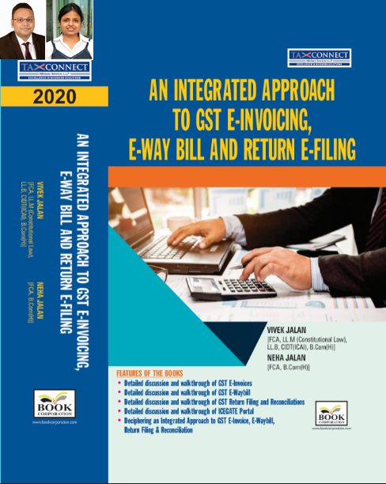

**ABOUT THE BOOK: This publication includes:**

1. **Detailed discussion and walkthrough of GST E-Invoices.**
2. **Detailed discussion and walkthrough of GST E-Waybill.**
3. **Detailed discussion and walkthrough of GST Return Filing and Reconciliations.**
4. **Detailed discussion and walkthrough of ICEGATE Portal.**
5. **Deciphering an Integrated Approach to GST E-Invoice, E-Waybill, Return Filing & Reconciliation**

**Authors:**

**Vivek Jalan**

***[FCA, L.LM (Constitutional Law), L.LB, CIDT(ICAI), B.Com(H)]***

**Neha Jalan**

***[FCA, B.Com(H)]***

**Published by:                                                                                                                                    In Association With:**

**BOOK CORPORATION                                                                                                            TAX CONNECT ACADEMY**

4, R. N. Mukherjee Road                                                                                                                     1, Old Court House Corner

Kolkata 700001                                                                                                                                                    Kolkata 700001

Phones: (033) 64547999                                                                                                                         Phones: (033) 40016761

Cell : 9830010297, 9331018333                                                                                                Cell : 9874466163, 9830661254

Order by email:[bookcorporation@gmail.com](mailto:bookcorporation@gmail.com)                                                                         Order by email: [info@taxconnect.co.in](mailto:info@taxconnect.co.in) Website :[www.bookcorporation.com](http://www.bookcorporation.com/)                                                                        Website : [www.taxconnect.co.in](http://www.taxconnect.co.in/)

**IN STANDS**

**Section wise Compendium on GST**

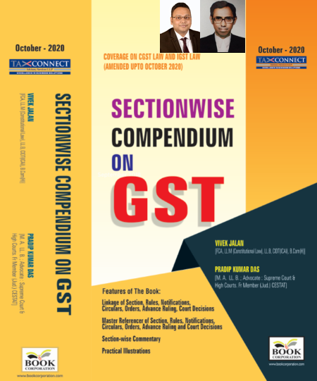

**ABOUT THE BOOK: This publication includes:**

**1. Linkage of Section, Rules, Notifications, Circulars, Orders, Advance Ruling, Court Decisions**

**2. Master Referencer of Section, Rules, Notifications, Circulars, Orders, Advance Ruling and Court Decisions**

**3. Section-wise Commentary**

**4. Practical Illustrations**

**Authors:**

**Vivek Jalan**

***[FCA, L.LM (Constitutional Law), L.LB, CIDT(ICAI), B.Com(H)]***

**Pradip Kumar Das**

***[M.A. LL.B; Advocate Supreme Court & High Courts; Fr. Mem (Jud.) CESTAT]***

**Published by:                                                                                                                                     In Association With:**

**BOOK CORPORATION                                                                                                            TAX CONNECT ACADEMY**

4, R. N. Mukherjee Road                                                                                                                     1, Old Court House Corner

Kolkata 700001                                                                                                                                                    Kolkata 700001

Phones: (033) 64547999                                                                                                                         Phones: (033) 40016761

Cell : 9830010297, 9331018333                                                                                                Cell : 9874466163, 9830661254

Order by email:[bookcorporation@gmail.com](mailto:bookcorporation@gmail.com)                                                                         Order by email: [info@taxconnect.co.in](mailto:info@taxconnect.co.in) Website :[www.bookcorporation.com](http://www.bookcorporation.com/)                                                                            Website : [www.taxconnect.co.in](http://www.taxconnect.co.in/)

**IN STANDS**

**UNION BUDGET 2021**

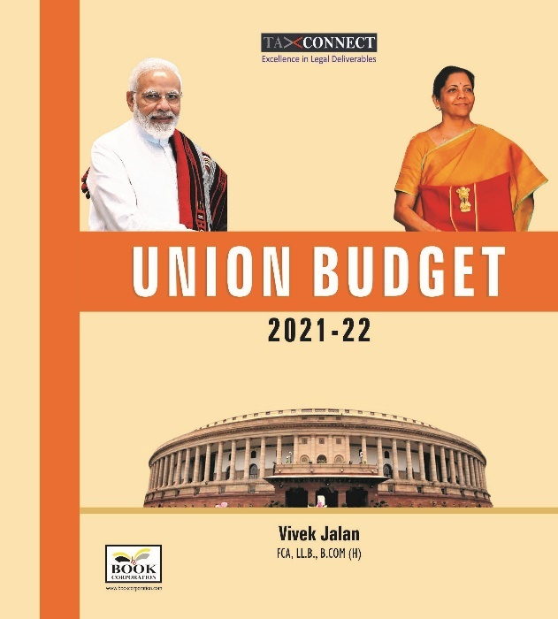

**ABOUT THE BOOK: This publication includes:**

**1.Commentary on Budget**

**2.Finance Minister’s Budget Speech**

**3.Budget at a Glance**

**4.Memorandum**

**a. Direct Tax**

**b. Customs**

**c. Excise**

**d. GST**

**5. Finance Bill**

**6. Notes on Clauses**

**Authors:**

**Vivek Jalan**

***[FCA, L.LM (Constitutional Law), L.LB, CIDT(ICAI), B.Com(H)]***

**Published by:                                                                                                                                     In Association With:**

**BOOK CORPORATION                                                                                                            TAX CONNECT ACADEMY**

4, R. N. Mukherjee Road                                                                                                                     1, Old Court House Corner

Kolkata 700001                                                                                                                                                    Kolkata 700001

Phones: (033) 64547999                                                                                                                         Phones: (033) 40016761

Cell : 9830010297, 9331018333                                                                                                Cell : 9874466163, 9830661254

Order by email:[bookcorporation@gmail.com](mailto:bookcorporation@gmail.com)                                                                         Order by email: [info@taxconnect.co.in](mailto:info@taxconnect.co.in) Website :[www.bookcorporation.com](http://www.bookcorporation.com/)                                                                            Website : [www.taxconnect.co.in](http://www.taxconnect.co.in/)

**LET’S DISCUSS FURTHER!**

**OUR OFFICES:**



**DUBAI**

Azizi Feirouz, 803, 8th Floor, AL Furjan, Opposite Discovery Pavillion, Dubai, UAE

Contact Person: Rohit Sharma

Email: rohit.sharma@taxconnect.co.in



**KOLKATA**

R No 119; 1st Floor; Diamond Arcade; 1/72, Cal Jessore Road; Kolkata – 700055

Contact Person: Priyanka Chowdhury

Email: priyanka.chowdhury@taxconnect.co.in



**KOLKATA**

1, Old Court House Corner, “Tobacco House”, 1st Floor, Room No. 13 (N), Kolkata-700001

Contact Person: Priyanka Chowdhury

Email: priyanka.chowdhury@taxconnect.co.in



**MUMBAI**

Building No.9, Flat- 403, LodhaEternis, 11th Road, MIDC, Andheri(E)-400093

Contact Person: Rajanikant Choudhury

Email: rajnikant.choudhary@taxconnectdelhi.co.in



**DELHI**

B-139, 2nd Floor, Transport Nagar, Noida-201301 (U.P)

Contact Person: Poonam Khemka

Email: poonam.khemka@taxconnectdelhi.co.in



**BANGALORE**

A-414,Carlton Towers, 19th Main; Road Hal Old Airport Rd, Domlur, Bengaluru, Karnataka-560008

Contact Person: Manmit Sinha

Email: manmit.sinha@taxconnectdelhi.co.in

**Disclaimer:**

*This e-bulletin is for private circulation only. Views expressed herein are of the editorial team and are based on the information, explanation and documents available on Government portal platforms. Tax Connect or any of its employees do not accept any liability whatsoever direct or indirect that may arise from the use of the information contained herein. No matter contained herein may be reproduced without prior consent of Tax Connect. While this e-article has been prepared on the basis of published/other publicly available information considered reliable, we do not accept any liability for the accuracy of its contents.*

Tax Connect 2021. All rights reserved.